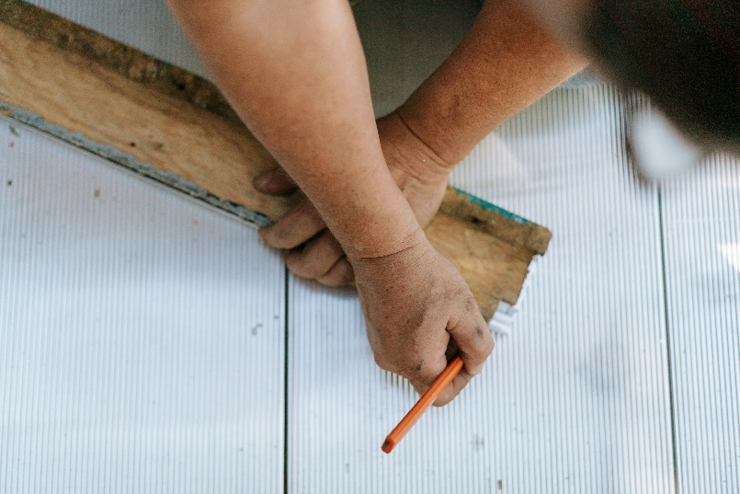
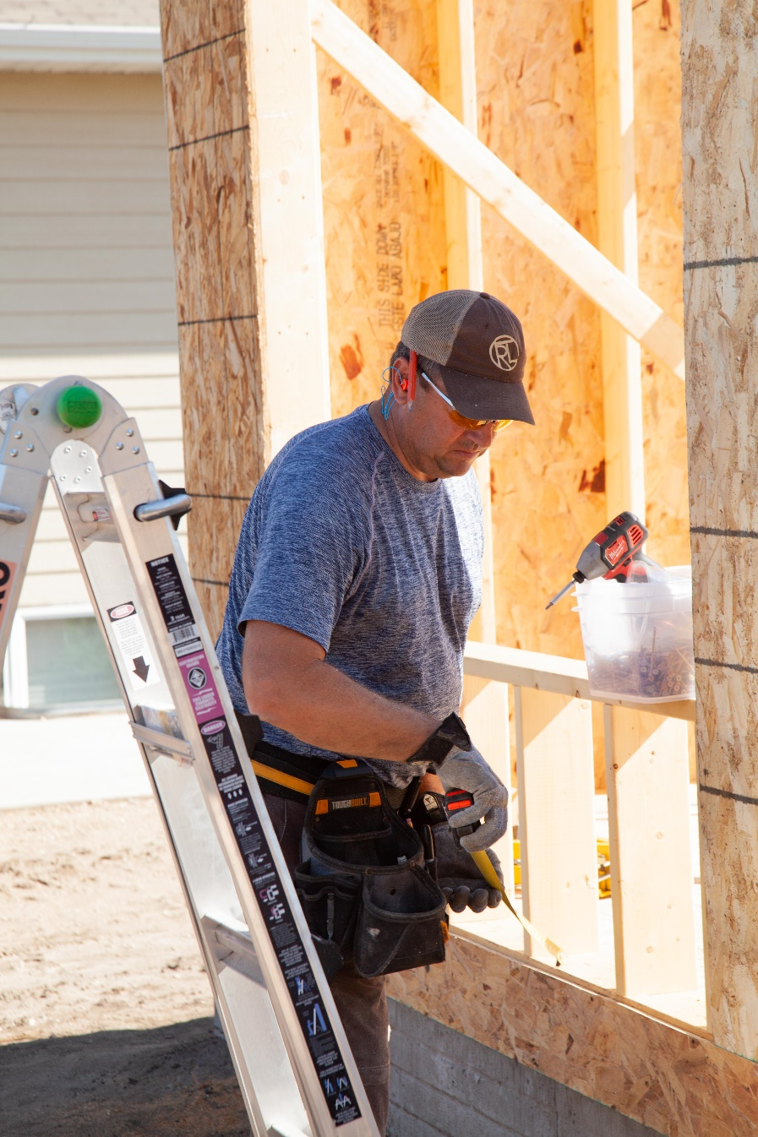
Homeowner Maintenance Manual

Table of Contents
Page
- Seasonal Maintenance Calendar………………………………….. 3
- Monthly, Semi-Annual and Annual Maintenance………… 6
- Homeowner Maintenance Inspections Checklist……….. 8
- New Home Installations & Maintenance Procedures
  - Maintenance inside your home…………………………….. 10
  - Maintenance outside your home………………………….. 24
- Homeowner Maintenance Recording Log…………………… 36
- Contractor Maintenance Recording Log…………………….. 37
- Appliance Service Records and Contacts…………………… 38
- Home Maintenance Repair Contractors……………………… 39
Glossary of Terms………………………………………………………….. 40
Notes………………………………………………………………………………… 44

- Seasonal Maintenance Calendar

Establishing and following a maintenance schedule is the best way to manage your household maintenance budget, to protect your investment and to prevent problems. This seasonal schedule of maintenance tasks should not replace the manufacturer’s recommendations. We suggest that you use licensed contractors for any tasks you may feel that you don't have the technical knowledge or ability to perform.

SAFETY FIRST- Homeowners often want to perform maintenance themselves to save money. It is important to bear in mind that there are many areas of home maintenance that are best left to professionals. For example, electrical work, entering an attic, or climbing on roofs and ladders are just a few hazardous activities. It is better to take the safe choice if there is any question as to the ability of the homeowner to perform any maintenance task.

Fall
- Check windows and doors on the exterior for possible air or water leaks· make sure the weep holes are clear at the bottom on the outside.
- Inspect caulking around windows for cracks or separation from the window or building.
- Check the roof for loose shingles, tiles or shakes. Make sure vents are in good condition and are not blocked with debris.
- If you have large trees or shrubs close to the home, make sure they are trimmed well back to avoid branches damaging the exterior of the home, the shingles or interfering with vents.
- Check for leaves and debris in gutters and eaves troughs - check for blockages at the down-pipe connections.
- Have gas heating systems inspected by a certified professional.
- Vacuum and clean out forced air registers (vents) and ductwork in your home.
- Remove the hoses and any diverter manifolds or other attachments from the hose bib itself.
- Remember to turn outside water outlets off and drain exterior faucets of water before winter! There are several kinds of outside water outlets. If you have only the frost-free type of hose bib it shuts off only from the outside of your home. Make sure all hoses and appliances are disconnected to allow water to drain out. You may have a frost-free type that also has an inside water shut-off valve. Shut off the inside valve, then open the outside hose bib to allow it to drain. You may have a non-frost-free type of hose bib with an inside shut-off. Turn off the water at the inside valve and open the outside valve to ensure the water drains. Some new homes have the hose bibs inside the garage or a utility room - these too should have the hoses disconnected and be drained, or have the water supply shut off and drained before freezing temperatures.
- Check CO (Carbon Monoxide) detectors if installed.
- Check all the vents outside your home; the combustion vent intake, the dryer vent and the range hood vent. Make sure they are all clear, functional and the screens are dean.

Winter
- Check the attic for leaks, check the insulation, look for blocked vents and look to see if any daylight is coming in through the roof or around chimneys (may indicate a leak or hole).
- Replace the furnace filters (homeowner), check fan belt and lubricate the motor if required (may require a technician).
- Clean and test all the smoke alarms - check or replace the batteries.
- Test all the Ground Fault Circuit Interrupters (GFCls) and all the panel breakers.
- Remove ice and snow from porches and concrete stairs as soon as possible- don't use salts or other chemicals that will damage the concrete to melt or disperse ice.
- In freezing or snow conditions check for ice dams on the overhangs of the roof.
- Occasionally open windows to allow the house to air out (weather permitting).
- Avoid overloading circuits with heaters, light decorations or appliances during the winter.
- Remember to remove and store all your hoses, turn off the water supply to the exterior faucets and drain hose bibs (remove diverters too) BEFORE freezing temperatures. (See the information under FALL).
- If you have an in-ground sprinkler system, make sure it is properly drained and winterized BEFORE freezing temperatures.
- Check that your faucets are not leaking - this will save you money especially on your hot water heating costs.
- Check all the CO (Carbon Monoxide) detectors for operation. This is especially important in winter.
- Do not pile snow against the side of your home.

Spring
- Clean and test all your smoke alarms (if needed replace batteries).
- Test all GFCls in bathrooms, kitchens, outside receptacles and on the electrical panel.
- Change the furnace filters and inspect the fan belt (may require a technician).
- Inspect the roof visually from the ground if possible (be safety conscious if you have to goon the roof or hire a contractor).
- Clean gutters and down-pipes and make sure downspouts and splash pads drain away from walls and foundation.
- Inspect caulking inside and out and touch-up or replace where needed with approved products.
- Clean windows, window tracks and make sure weep holes are not blocked (including sliding door tracks - lubricate openers and track rollers with silicone spray).
- Remember to turn on the interior water supply to hose bibs and exterior faucets! (IMPORTANT - check for leaks).

Summer
- Remove debris from gutters, eaves troughs and down-pipes. Hose them out and ensure good drainage flow.
- Examine window and door seals and repair as necessary. This will cut down on energy costs for cooling.
- Examine and repair grout in bathrooms and tile floors to prevent moisture damage materials' shrinkage may occur during the hot season
- Inspect and lubricate garage door roller shafts (do not attempt to adjust door springs yourself - always call a technician).
- Lubricate locks on doors and windows with silicone spray.
- Check window screens and screen doors for tears if installed.
- Check the condition of concrete slabs and sidewalks and asphalt driveways - repair cracks as necessary.
- Make sure sprinklers and hoses are not directed against the outside of the house.
- Make sure that plants and bushes do not grow up against the outside of the house (moisture can stay trapped and not dry causing damage).
- Check all landscaping and outdoor features to ensure good drainage away from the house, if the ground has settled or water is running back toward the house.
- Make sure all your drainage systems are working properly and that water drains away from your home. If it does not, take corrective actions immediately.
- Check to ensure there are no insects or vermin getting into your home.

- Monthly, Semi-Annual and Annual Maintenance

This general schedule identifies some of the more common maintenance tasks that may be performed on a monthly, semi-annually or yearly basis. Adjust this schedule to fit your own home and situation by adding or deleting maintenance items as needed.

As a homeowner, you have maintenance responsibilities for your new home and for the warranty. Establishing a maintenance schedule is a good way to manage your maintenance activities and maintenance budget.

This suggested maintenance list and schedule should not replace the manufacturer's recommendations. It is strongly suggested homeowners make use of licensed contractors for any maintenance items they feel unqualified or uncomfortable to perform. When in doubt, it is always best to consult a reputable contractor.

Suggested Monthly Maintenance Schedule
- Smoke Detectors - Check operation by pushing test button to cause it to emit sound - if it does not check the circuit breaker. Check and replace the battery when necessary. (Most detectors will emit an intermittent beep when the battery is failing).
- Check CO (Carbon Monoxide) detectors if installed.
- Check the fire extinguishers for proper charge levels indicated on the gauge. Homeowners may contact their local Fire Department for recommendations on the appropriate number of extinguishers and the best locations to place them.
- Test all GFCls to ensure proper operation.
- Clean in-sink garburator blades by grinding small ice cubes while running cold water down the drain (this will remove food debris which causes odors).
- Clean or replace range hood filter and make sure it exhausts properly.
- Check for signs of water leaks around toilets, under sinks and around dishwasher regularly.
- Clean and freshen sink drains by flushing with a diluted bleach and water mix, or with warm water and baking soda.
- Inspect and clean or replace furnace filters, humidifier plates or drums and electronic air filters. Clean with a calcium and rust remover or replace as required per the manufacturers' recommendation.
- Clean aerators on faucets regularly and check screens in washing machine supply hoses.
- Check water filters and water softener appliances regularly. The life of the filters is dependent upon water usage and local water conditions.
- Clean your dryer lint trap regularly, if your home has a booster fan installed be sure to check and clean the lint trap in that as well. Damaged or torn lint traps should be replaced.
- Check the Temperature Pressure Release (TPR) valve on the water heater. The hot water tank should also be drained every six months to prevent sediment build up. Follow the manufacturer's recommendation to turn off gas or power and protect against hot water burns.

Semi-Annual Maintenance Schedule
- Inspect the roof and chimney (if brick) for broken or missing tiles or shingles, to identify anything that might cause leaks or problems.
- Inspect and clean gutters, down-pipes and down spouts.
- Inspect the outside of the home for the condition of siding, paint, masonry, stucco or other cladding and wood trim.
- Inspect and operate doors and windows to ensure proper operation, security and weather resistance.
- Check all the caulking in your home around sinks, tubs, showers and toilets to ensure it is in good condition and there are no leaks, gaps, see page on mildew.
- Check under all the sinks and other water fed appliances to ensure there are no drips or signs of leaks.
- Inspect all windows and doors and masonry to ensure the weep holes are clear.
- Clean tracks of windows and sliding glass doors before applying silicone spray lubricant.
- Inspect the foundation, basement or crawl space for abnormal conditions or cracks.
- Inspect the main electrical panel, circuit breakers and all GFCI outlets and breakers.
- Perform complete seasonal maintenance on the heating system.

Annual Maintenance Schedule
- Examine caulking around windows and doors and repair or renew as necessary.
- Inspect condition of concrete slabs and patios for cracks and spalling.
- Ensure toilets flush properly and there are no odors in the area of the tank or field.
- Check all interior and exterior wood trim and touch-up or repair as necessary.
- Have annual heating system/furnace and hot water tank maintenance performed by a licensed contractor (this is to ensure proper calibration and safety- especially in the case of gas furnace and hot water tank).
- Schedule professional inspection of all major appliances particularly if gas fueled (as above - furnace, hot water tank, gas ranges or cooktops etc.).
- Inspect paint finishes inside and outside the home- clean or repair and repaint as required.
- Have fireplace chimney or vents inspected and cleaned by a professional cleaner.

- Homeowner Maintenance Inspections Checklist

The Building Envelope – The Exterior of your Home.

It is recommended homeowners photocopy these pages for re-use. The frequency of inspection stated is a minimum and should be increased should conditions warrant.
Item to Inspect | Inspection Frequency | Inspect For | Checked Month/Year
Roofing | Monthly Semi-Annually Spring & Fall | A cursory monthly check is intended to spot physical damage or drainage problems. This check is purely a visual inspection for damaged or missing shingles/tiles or flashing. Have a contractor remove debris (leaves, twigs etc.). Failure to maintain the roof will void the warranty.
Flashing | Semi-Annually Spring & Fall | Physical damage. Look for flashing which may have been damaged or bent by gardeners, window cleaners or other operations around your home. Roof flashing should be inspected when the roof drainage is being checked. Damaged flashings must be repaired or replaced as necessary or warranty may be voided.
Decks & Deck Drains | Monthly | Drain blockage, or physical damage. Individual deck drains should be checked frequently during the rainy season and when debris is most prevalent in the fall. Check the deck membrane for cracks, splits or other damage when cleaning.
Sealants Caulking | Semi-Annually Spring & Fall | Look for damage or obvious sealant failure when cleaning windows or decks.  Sealant which is cracked, split, de-bonded, discolored, is peeling, or is otherwise different in appearance from when it was installed should be replaced.  Check sealant condition around masonry, stucco and flashing saddle connections. Check also around windows, doors, sliding patio doors and any wall penetrations.  If any abnormalities are noted caulking must be replaced. Use only approved caulking products
Paint | Semi-Annually Spring & Fall | Painted areas on your house protect wood and other materials from damage and wear from the effects of water and weather.  Observe condition of paint when cleaning windows or decks. Look for peeling, blistering, chalking or fading paint.  If any painted components of your home show any signs of being diminished those areas should be cleaned, repaired or repainted as necessary.
Vents | Semi-Annually Spring & Fall | Regular cleaning of dryer lint screens will reduce the necessity to clean the exterior vent covers.  Dirty or blocked exterior covers can lead to moisture accumulation in the vent pipe and cause leakage and deterioration.  Check any screens or grilles in front of vents to ensure birds or small animals cannot enter the building.  Check vent covers regularly.
Landscaping | Annually | While plants and landscaping are not covered by your new home warranty you must ensure that conditions and any changes you make to your landscaping do not cause damage to your home.  Plants growing directly adjacent to or in contact with the building exterior can reduce the drying potential of the exterior cladding and increase the likelihood of problems. Keep plants and shrubs away from exterior walls.  The finished grade of your lot was sloped to allow water to drain away from your home. You must maintain positive grading of the yard in any way that permits water to be directed away from the foundation of your house or out buildings. If there is settling around the foundation or below decks you may have to add extra soil.  Clear leaves, dirt and debris away from your house.  Check the operation of sprinkler systems to ensure they are not directing water against the outside of the house.  Monitor conditions during heavy rain to ensure water drains away from the house and foundation. Do not piles now against the side of the home.
Doors | Semi-Annually Spring & Fall | Doors should be checked in order to assess the hardware and the perimeter seals. Poorly operating mechanisms or weather-stripping should be repaired or replaced.  Ensure the weather strip is intact and seals properly, that the door is not warped, check the finish for paint or stain and check the caulking around the door frame and near the door sill.  Check to ensure the doors are not delaminating or splitting.
Walls | Monthly | Investigate any staining or moisture on the drywall side of exterior walls. Note the weather conditions when the moisture appears. If there are signs of mold or water stains on the inside walls of your house, it is critical that there be further investigation.
Windows | Semi-Annually Spring & Fall | Inspect window frames, hardware, flashings and sealed units to ensure that they are in good working condition.  Homeowners should replace any weather stripping, seals or hardware that are damaged or inoperable. Weep holes at the bottom of the windows should be checked to ensure they are clean and free of debris.  Check for condensation between the panes of sealed glazed units. If there is condensation the seal has failed and the window should be replaced.

- New Home Installations & Maintenance Procedures
  - maintenance inside your home

Air Conditioning
Air conditioning may not be a standard feature in all new homes. If your home has air conditioning, or you have one installed after closing date, please refer to the manufacturer's operating and maintenance instructions.

Appliances
All your new appliances have been installed and tested for operation in your home. The manufacturer's appliance warranties take effect on the date of closing. The appliance manufacturer's warrant their products directly to you according to the terms and conditions of the warranties they provide with the appliances. Your builder will ensure that those documents are in your home when you take possession.

Attic Access
Attic space is not designed or intended for storage. Access to the attic is for the inspection and maintenance of insulation, vents, chimneys, or other mechanical equipment that may be installed in the attic. If you or any service people perform maintenance or inspections in the attic, use great caution and avoid stepping off wood members onto the drywall under the insulation. Stepping off the trusses or wood members can result in personal injury or damage to the ceiling below. Your limited warranty does not cover such injury or damage.

Brass Fixtures
Manufacturers often treat brass fixtures with a clear protective coating to protect and reduce maintenance. The coating can be damaged by intense sunlight and caustics or mineral spirits such as acetone found in nail polish remover. The finish can also be damaged by scratches or chips from sharp objects. Any damage resulting from these conditions is not warrantable by the manufacturer or your new home warranty.

Cleaning
Care of these coated products requires only periodic cleaning with a mild household cleaner.
Tarnish
Like sterling silver, any uncoated polished brass will gradually tarnish and eventually take on an antique appearance. Use an approved product to clean and polish unfinished brass.

Cabinets
Your builder may have left information about your cabinets. If you have wood or wood veneer cabinets, it is normal and acceptable that there will be differences in grain and color between the cabinet components due to natural variations in wood and the way it takes stain. Since wood is a product of nature these variances in wood must only be matched to within a reasonable limit, as perfect matches in grain or color of the wood are impossible.

Cleaning
Products such as lemon oil or polishes that include scratch cover are usually recommended for wood cabinet care by the manufacturer. Follow the cabinet manufacturer's directions, or the cleaning product directions. Avoid washing cabinets with water or ammonia cleaners.

Cabinets with synthetic finishes such as melamine can usually be cleaned with mild soapy water and dried immediately afterward. If in doubt, consult the manufacturer's recommendations for care and cleaning.

Hinges
If cabinet doors become misaligned, most new cabinet hardware can be adjusted by homeowners with ordinary household tools. If hinges catch or drawer glides bind or stick, a small amount of silicone lubricant will help. If lubricant does not help check to ensure nothing is inhibiting movement, or the cabinets or hardware have not been damaged in some way.

Moisture
Damage to cabinet finishes and door warping can result from using appliances that generate large amounts of heat or moisture (such as counter-top ovens, crockpots or water kettles) too near the cabinet. When using such appliances, be aware and place them in a location that is not directly under a cabinet or near furniture which can be damaged

Carpet
Homeowners should be provided a record of the brand, style and color of floor coverings in your new home. Please keep this information for future reference and refer to the manufacturer's recommendations for information on the care of your floor coverings.

Cleaning
Your carpeting will have a manufacturer's warranty depending on the style and quality you purchased and whether it was factory treated with a stain resistant material. Have your carpet professionally cleaned regularly, typically after 18 months in your home and then once a year after that depending on local conditions.

Crushing
Furniture and traffic may crush a carpet's pile fibers. Moving your furniture to change the traffic pattern in a room promotes even wear and reduces the effects of crushing. Heavy traffic areas such as halls and stairways are more susceptible to wear and crushing. This is considered "normal wear and tear" and is not warrantable.

Stains
Some carpets are stain-resistant, but this does not mean the carpet is stain-proof. Always refer to the manufacturer's recommendation for cleaning or consult a professional cleaner who will understand the various coloring and chemical constituents of your particular carpet.

Static
Dry air in the home can often contribute to static electricity discharges. One solution is to select carpet sat pre-construction that have an anti-static treatment, or homeowners may install a humidifier to moisten the air within the home to acceptable levels which may reduce static charge buildup.

Caulking
Over time caulking may dry out and shrink so that it no longer provides a good seal between baseboards and walls, or between millwork counter or vanity tops and walls. In wet areas silicon e caulking may shrink, de-bond, or show signs of mildew. As part of your routine maintenance check caulking monthly and repair or replace as necessary.

Latex Caulk
Latex caulking is non-toxic, cleans up easily and is used in areas that require painting. Latex caulk is a homeowner maintenance item and part of normal maintenance, renovations and painting.

Silicone Caulk
Silicone caulking is used where water is present, for example, where the tub meets tile or at shower stall doors, or where a sink meets a countertop (especially under-mount sinks).Silicone caulking is not paintable and contains acetic acid which gives off an odor while curing. Read the instructions on the product container.

Temperature
Keep your home heated to a normal, comfortable, recommended living range between 20- 22 degrees Celsius. Excess heat or cold may cause excess shrinkage, or excess moisture in your home.

Humidity Guide
Outside Air Temperature in Fahrenheit | Outside Air Temperatures in Celsius | Desirable Maximum Inside Relative Humidity (%) at an Indoor Temperature of 21 C (70 F)
-20 | -29 | 20%
-10 | -24 | 25%
0 | -18 | 30%
10 | -12 | 35%
20 | -7 | 40%

Ventilation
Ensure that bathroom fans operate while showering or bathing and are left on until all excess moisture in the bathroom has dissipated.
Countertops
Use a cutting board to protect your counters when you cut or chop. Protect the counter from heat and from extremely hot pans. If you cannot put your hand on it, do not put it on the counter. Do not use countertops as ironing boards and do not set lighted cigarettes on the edge of the counter. Do not use countertops to pound objects on or use them to sit on.

Caulking
The caulking between the countertop and the wall, along the joint at the backsplash (the section of counter that extends a few inches up the wall along the counter area) and around the sink may shrink, leaving a slight gap. If a gap occurs water may seep below the countertop causing damage to the countertop or to the cabinets below. Maintaining a good seal in these locations is important to keep moisture from reaching the wood under the laminates and to prevent warping.

Separation from wall
Countertops will separate from walls, backsplashes and around sinks. This is a normal occurrence due to the normal shrinkage of materials. Maintaining the caulking is part of the homeowners' maintenance responsibilities.

Cleaning
Follow the manufacturer's recommendations for cleaning.

Laminates
Laminated (millwork) countertops will have seams at any mitered intersections and it is normal that these will be visible. You should avoid letting water stand on any countertop seam.

Doors and Locks
Doors inside new homes are wood product5and are subject to shrinkage and warpage if the humidity level of your home is not maintained at an acceptable level, or if the finish (paint or stain etc.) is damaged and left un-repaired. Normal fluctuations in humidity levels from the use of forced air furnaces, showers, cooking and dishwashers, may result in interior doors occasionally requiring minor adjustments.

Bi-Fold Doors
Bi-fold doors may shrink or warp slightly and may also require some adjustment to re-align them. If they bind in the hardware apply a silicone spray lubricant to the track at the top of the door.

Failure to Latch
If a door will not latch because of minor settlement of the structure, the latch plate can be adjusted as necessary. Before adjusting the latch plate check that the hinge screws are tight.

Hinges
If hinge son swing doors in your home squeak, apply a silicone spray lubricant to correct this.

Locks
Lubricate door locks with silicone spray or another non-staining, waterproof lubricant. Avoid using oil, as it may solidify and become "gummy ''.

Shrinkage
Use putty, filler or latex caulk to fill any minor cracks or separations that typically occur at mitered joints in door trim. Sand and paint with the matching paint included in your new home paint touch-up kit. The need for paint touch-ups to walls and woodwork due to normal wear and tear is a homeowners’ maintenance responsibility.

Sticking
The most common cause of a sticking door is the natural expansion of the door or framing lumber caused by changes in humidity. If doors stick, check and tighten the hinge screws that hold the door jamb or door frame. If light planing is necessary after trying this, use sandpaper to smooth the door and paint or stain the sanded area to seal it. If the sticking is excessive contact your builder to ensure there isn't a more serious problem.

Warping
Doors may warp slightly; this is normal. If the warping is not excessive, keeping the door closed as much as possible may return it to its original shape. Avoid having items leaning against open doors that are tight against the door stop. Acceptable warping fluctuations should not exceed 6 mm (1/4") of deflection.

Weather Stripping
Weather stripping and exterior door thresholds occasionally require cleaning and adjustment or replacement.

Panel Shrinkage
Panel inserts of wood doors shrink and expand in response to changes in temperature and humidity. Touching up the paint or stain on unfinished exposed areas is your home maintenance responsibility. If any splitting occurs contact your builder.

Drywall
Slight cracking, nail pops, or seam joints may appear in walls and ceilings. These are caused by the shrinkage of the wood and normal deflection of wall studs, trusses or rafters to which the drywall is attached.

Repairs
Your builder will provide a "one time repair" of drywall cracks or nail pops caused by building settlement. Normally homeowners are requested to wait until they have occupied the home for at least10 months prior to requesting repairs be performed by the builder to allow sufficient time for the building to settle and acclimatize to local humidity conditions. If there are large cracks or if cracks appear in places which impair the enjoyment of your home, contact your builder.

Onetime Repairs for 1st Year Warranty
One time during the materials and workmanship warranty, your builder will repair drywall shrinkage cracks and nail pops and may touch-up the repaired area using the same paint color that was on the surface when the home was delivered. Touch- ups may be visible depending on the paint type, age and conditions in the home. It is not the responsibility of your builder to repaint the entire wall or the entire room to correct touch-up mismatch. Homeowners are entirely responsible for custom paint colors or wallpaper that has been applied subsequent to closing.

Lighting Conditions
Drywall flaws that are only visible under particular lighting conditions are not considered a warrantable defect.

Related Warranty Repairs
If a drywall repair is needed as a result of poor workmanship (such as blisters in the drywall joint tape) or are due to another warranty-based repair (such as a plumbing leak), your builder completes the repair by touching up the repaired area with the same paint that was on the finished surfaces when your home was delivered. Typically, if more than one-third of the wall is involved, your builder may repaint the wall corner to corner. Homeowners are responsible for custom paint colors or wallpaper that has been applied subsequent to closing.

Electrical System
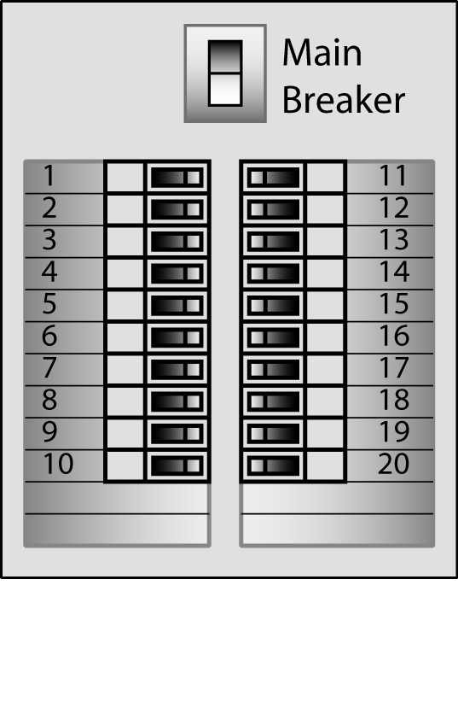During your orientation of your new home you will have been shown the main electrical breaker panel that includes a main shut-off that controls all the electrical power to the home. Each breaker is marked to help you identify which breaker is connected to each major appliances, outlets or other service. If a power failure occurs in any single part of your home, always check the breakers in the main panel box first.

Breakers
Circuit breakers have three positions: ON, Off and TRIPPED. When a circuit breaker trips it must first be turned off before it can be turned back on. Switching the breaker directly from TRIPPED to ON will not restore power service.

Breakers Tripping
Breakers usually trip because of overloads caused by plugging too many appliances into the circuit, a worn cord or defective appliance, or operating an appliance with too high a voltage or wattage requirement for the circuit. The sudden starting of an electric motor can also trip a breaker. If a breaker trips repeatedly check for any of the above causes.

Buzzing
Fluorescent fixtures use an electrical transformer called a “ballast” to operate. The voltage reducing transformer sometimes causes a buzzing noise and is normal unless the noise is excessive. If the noise is excessive or the lights have a delayed starting period, or flicker constantly, the ballast may be defective.

Fixture Location
Moving fixtures to accommodate furniture arrangements or special needs is a homeowner responsibility. It is recommended a qualified electrician be consulted.

Ground-Fault Circuit-Interrupters (GFCI)
GFCI receptacles have a built-in element that senses small fluctuations in power. A GFCI is just another type of circuit breaker, only more sensitive. Building codes require installation of these receptacles near water sources such as in bathrooms, the kitchen, outside and the garage (areas where an individual can come into contact with water while holding an electric appliance or tool).

There are GFCI receptacles (plugs) which are installed inside and outside your home and there are GFCI breakers which are installed in the electrical panel.

Each GFCI circuit has a TEST and RESET button, each of which is usually colored differently from the GFCI itself and will be clearly marked. Once each month, press the TEST button. This will trip the circuit. To restore service, press the RESET button. If a GFCI breaker trips during normal use, it may indicate a faulty appliance and you will need to investigate the problem. One GFCI breaker can control up to two outlets.

Grounded System
Your electrical system is a three-wire grounded system. Never disconnect or remove the bare wire that connects to the box or device and never remove the ground pin (long round one) from an appliance cord plug.

Designed Load
Your builder or his electrical contractor will repair any electrical wiring that fails to carry its designed load to meet specifications. Overloading circuits beyond the design load limits is not covered by your warranty.

Glass Doors
On fireplaces with glass enclosed fireboxes a white haze will appear on the inside of the glass. This is a normal accumulation of minerals which are the by-product of combustion. Glass enclosures can be removed for cleaning according to the instructions in the manual. Use only approved cleaners available at the fireplace supplier or home hardware stores.
Do not use household cleaners with ammonia or detergents.

Water Infiltration
In periods of unusually heavy or prolonged precipitation or precipitation driven by high winds some water can enter the fireplace and the home through the chimney. This is not a defect under the terms of your limited warranty.

Floor Drains
Pour water down the floor drains in the basement area to ensure they are clean and functioning. The reason for this is to prevent sewer gas from backing up the pipes and getting into the home. Some districts or municipalities require that floor drains incorporate automatic primers to replenish the water in the trap. In homes that do not have the automatic type occasional filling with water may be required to keep them full.

Gas Shut-Offs
SAFETY FIRST -You will find shut-offs on gas lines near their connection to each item that operates on gas such as your gas furnace , gas hot water tank, fireplace, gas range or cooktop, or outside barbeque connection. In addition there is a main shut-off controlling gas to the entire home at the meter

Gas Leak
If you smell or suspect a gas leak leave the home and call the gas company immediately for emergency service.
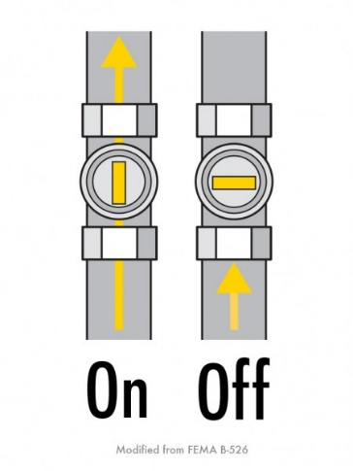

Hardware
Doorknobs and locks should operate correctly with little maintenance. Occasionally they may need slight adjustments due to normal shrinkage of the framing, doorframe or the doors. On occasion homeowners may need to tighten screws or lubricate the handles and hinges with silicone spray lubricant.

Hardwood Floors (Laminates)
In the maintenance of hardwood floors preventive maintenance is the primary goal.

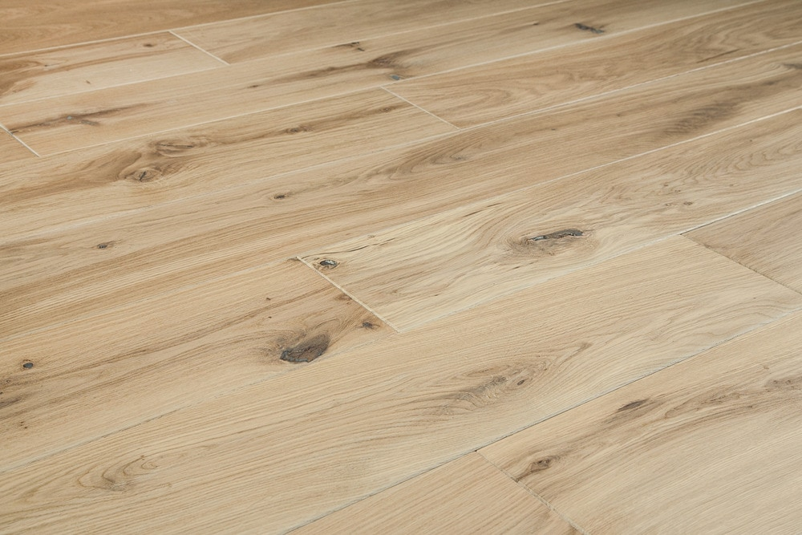

Cleaning
Sweep on a daily basis or as needed. Never wet-mop a hardwood or laminate floor unless the manufacturer approves doing so. Excessive water can enter the gaps between boards at joints and can cause the wood to expand and can damage the floor. When polyurethane finishes on laminate become dirty refer to the manufacturer's cleaning recommendations.

Dimples
Placing heavy furniture, dropping heavy or sharp objects, or walking with high heeled shoes on hardwood floors can result in dimples or cuts or bruise damage. These are homeowner damage and not covered by your new home warranty.

Furniture Legs
Install proper floor protectors (felts or glides) on the legs of any furniture placed on hardwood floors. Protectors will allow chairs and larger furniture to move more easily over the floor without scuffing or scratching. Regularly clean or replace the protectors to remove any grit that may have accumulated which can cause scratching or wear of the surface of the floor finish.

Humidity
Wood floors may respond noticeably to changes in humidity in your home. During winter months the individual planks or sections can expand and contract as water content changes. Laminate floors are typically "floating floor" assemblies and are not attached to the sub-floor so some movement may be noticed. This is normal unless there is buckling or if squeaks develop at transition strips.

Mats and Area Rugs
Use protective mats at the exterior doors and entries to help prevent sand and grit from damaging the floor. Hard mats such as "coco" mats should not be used and all mats should be taken up frequently for cleaning of any dirt or grit that might get between the mat and the floor surface and cause damage. Some rubber backing on area rugs or mats can cause yellowing and warping of the floor surface. Placing area rugs or mats on floors in direct sunlight may cause uneven fading or yellowing and is not warrantable.

Separation
Expect some shrinkage which will be noticed at the joints of the wood plank or board sections near heat vents or any heat-producing appliances, or during seasonal weather changes.

Shoes
High heel shoes can exert over 8,000 pounds of pressure per square inch on the floor under the heels. Wearing of high heeled shoes on hardwood or laminate floors is not recommended under any circumstance and any damage resulting is not covered by warranty.

Spills
Clean up food spills immediately with a dry cloth. Never allow water or any liquid to stand on the wood or laminate floor.

Splinters
When wood or laminate floors are new, small splinters of wood can appear at the joints. Care is taken to remove these prior to the homeowner taking possession of the home, but the nature of natural wood may mean that a few splinters do appear. To remove them, carefully use a sharp object like a razor knife to cut them - do not pull at a splinter in case it tears along the wood grain and damages the board.

Sun Exposure
Exposure to direct sunlight can cause irreparable damage, discoloration or fading to hardwood floors. To maintain your hardwood or laminate floors install and use window coverings in these areas.

Traffic Paths
Eventually the foot traffic in traffic paths will wear the finish - this is normal wear and tear.

Warping
Warping will occur if the floor repeatedly becomes wet or is thoroughly soaked. Laminate floors may absorb the water and buckle and be destroyed. Unless the water damage is a result of a structural defector finishing defect, water damage will not be covered.

Separations
Shrinkage will result in separations between the members of hardwood floors. If these exceed 2 mm, your builder will fill them one time.

Heating System: Gas Forced Air
Proper maintenance of your furnace can save fuel costs and prolong the life of the furnace. Carefully read and follow the manufacturer's literature on use and maintenance.

Adjust Vents
Experiment with the adjustable floor or ceiling registers in your home to establish the best heat flow for your lifestyle. You may reduce the heat in seldom-used rooms, but do not turn it off completely in cold conditions.

Combustion Air
Furnaces installed in basements, or in utility closets in garages or over crawl spaces have an outside combustion air duct. This combustion vent allows unrestricted fresh air into the combustion chambers of the gas furnace and gas heater. The end of this duct on the outside of your home is covered with a screen to restrict insects or small animals from entering the duct. Cold air coming in though this duct means it is functioning as it should.

Caution: Never cover or block the combustion air vent in anyway at the outside of your home or inside your home where the vent terminates. Outside air is needed to supply the furnace with sufficient oxygen to supply the flame. Blocking the combustion air vent will cause the furnace to draw air down the vent pipe and pull poisonous gases back into your home. If your home is not equipped with CO (Carbon Monoxide) sensors, or they are not functioning properly Carbon Monoxide poisoning may occur.

Ductwork Noise
Some popping or pinging sounds are the natural result of ductwork heating and cooling in response to changes in the temperature of the airflow as the system operates. As ductwork and vents expand and contract noise is the result.

Filters
Keeping furnace filters clean will save on fuel and heating costs and help in keeping the inside of your home as dust free as possible. Change or clean the filter monthly during the heating season. Clogged filters can slow airflow and cause the fan to run too long and can create cold spots in your home.
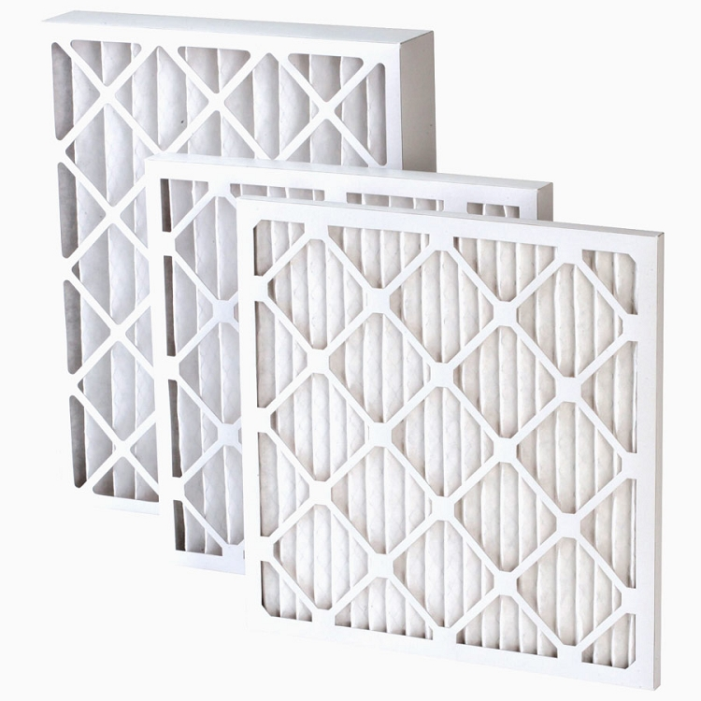
Gas Leak
If you smell or suspect a gas leak leave the home and call the gas company immediately for emergency service.

Odor
A new heating system may produce an odor for a few moments when you first turn it on. An older system may emit an odor after being unused for an extended time (such as after the summer months). This is caused by dust that has settled in the heating elements and in the ducts and should pass quickly. If it does not, turn the heating system off and call a qualified service person.

On-Off Switch
The furnace has an ON-OFF blower switch. This switch is the same as a regular light switch and is located either on a metal box near the furnace or is mounted on the wall outside the furnace room and will be labeled. When turned off, this switch overrides all furnace commands and shuts down the blower and the furnace cannot operate.

Registers
Heat register covers are removable and adjustable. Homeowners are responsible for adjusting the grilles in these covers to regulate the heat flow within the home.

Return Air Vents
In the home there are several grilles attached to the walls just above the floor. These are cold air return vents for the heating system. It is important that these areas are kept free of obstructions such as furniture or drapes, which will block the return airflow to the furnace causing it to operate inefficiently

Humidifier
Operate a humidifier according to the recommendations of the manufacturer. If you notice condensation on windows, either the humidifier should be adjusted to a lower setting or there is a source of excess moisture in the home. The humidifier is an appliance - refer to the manufacturer's limited warranty for information regarding coverage of the humidifier.

Paint and Stain
Avoid abrasive cleaners, scouring pads, or scrub brushes on any paint surface since these will cause damage. If cleaning with soap and water is not successful a commercial cleaner may be required followed by touch- up of the paint.

Stain
The same stain or closely matching products can be obtained for minor interior woodwork stain touch-ups.

Touch-Up
When doing paint touch-ups use a small brush, applying paint only to the damaged spot. If the paint is a latex eggshell, the best way to apply the paint is to "stipple" the paint on with the tip of the brush. Stippling means to blot or dab the paint on with the brush instead of applying long strokes.

If the painted surfaces are dirty or aged, the touch-up may not match the surrounding area even if the same paint from the homeowner touch-up kit is used. If the paint does not match the entire wall may require painting. This is not the responsibility of your builder or covered by your warranty.

Wall Cracks
It is suggested that you wait until after the first ten months from the date of possession to request that your builder repair drywall cracks or other separations due to shrinkage. The reason for this is that normal settlement and the adjustment of moisture contents of the building materials take time to reach normal and stable humidity levels.

After your "one time repair" of drywall cracks, homeowners are responsible for all subsequent touch-up, except any painting your builder performs as part of another warranty repair.

Cracking
With normal aging wood trim at window sills and door sills may develop minor cracks, or raised grain. Most of this will typically occur during the first year. Raised grain will permit moisture to get under the paint and can result in peeling or warping of the boards when they are near areas of sun exposure, moisture and temperature variations. This is not a defect in materials or workmanship and is not covered by your warranty. Paint finish maintenance of wood trim is a homeowner responsibility.

Plumbing
Your plumbing system has many components, most require little maintenance such as piping inside walls and drainage systems. Making sure you use fixtures properly, only flushing appropriate waste down toilets, checking faucet and hose screens and draining your hot water tank as part of routine home maintenance will ensure long life of all plumbing components.

Cleaning
Always follow manufacturer's directions for cleaning fixtures.

Clogs
The main causes of toilet clogs are household items being dropped in such as disposable diapers, excessive amounts of toilet paper, sanitary supplies, Q-tips, dental floss and children's toys to name a few. Improper garbage disposal use also causes many plumbing clogs.

Always use plenty of cold water when running the garburator disposal unit, do not force any material into the appliance and allow sufficient time for material to be chewed up by the blades of the unit to prevent clogs.

Never flush or wash hot or cold grease or oil down a drain. In particular, hot grease or oil will travel down the pipes and when it cools it will congeal and then stick to the pipe wall eventually causing blockages. This is not covered by your warranty.

Dripping Faucet
Most new plumbing fixtures use a washer-less cartridge. If these wear or become damaged the best solution is to replace them with new units. If your builder has installed faucets with washers contact your plumber or refer to the manufacturer's information on how to replace them.

Fiberglass Fixtures
For normal cleaning use a non-abrasive bathroom cleanser and sponge or a soft cloth. Avoid steel wool, scrapers and scouring pads, or anything that could damage the finish. Commercial polishes are available for cleaning and stain removal and which apply a protective finish. Consult your plumbing supplier or a home supply store.

Freezing Pipes
In freezing temperatures set the heat at a minimum of 12 -14 degrees C. Keep garage doors closed to protect plumbing lines running through or into the garage area from freezing temperatures (furnace and hot water tank rooms.)
In sub-zero freezing weather or if no one will be in the home for a time, open cabinet doors to allow warm air to circulate around pipes under sinks and for refrigerator water line installations. If pipes freeze, call a plumbing service company to thaw them properly.

Jetted Tubs
If your home includes a jetted tub follow manufacturer directions for its use, care and cleaning.

Leaks
If a major plumbing leak occurs, the first step is to turn off the main water supply to the home. If a major water pipe leak occurs it is better to minimize the damage and allow the plumber to identify and isolate the source of the leak.

Low Pressure
If pressure is low throughout your home contact a plumbing service company. If pressure is only low at one faucet or outlet check that the service valve is fully open, that the faucet aerator is not plugged or if it is the washing machine, that the supply hose screen is not blocked.

Main Shut-Off
The water supply to your home can be shut off entirely in two locations. The first is at the street and the second is at the meter. Your builder will show you where and how to turn off the main water supply in your home during your orientation.

Outside Faucets
Some outside hose bibs are self-draining and freeze-proof, but in order for this fixture to be effective you must remove hoses during cold weather even if the faucet is located in your garage - and especially before freezing weather. If a hose or flow diverter is left attached, the water that remains in the hose and hose bib can freeze and expand back into the pipe, causing a break in the line. If your home is not equipped with a frost-free (self-draining) style of hose bib there will be a water shut-off somewhere inside the home. It is important that you learn where these water shut-off valves are and turn them off- then drain the hose bib properly to prevent water from freezing inside it and bursting the hose bib or the supply pipe.

NOTE: Neither your builder nor your warranty provider warrant hose bibs against freezing and water damage occur it is the private insurance of the homeowner to deal with a claim.

Porcelain
You can damage porcelain enamel in sinks and bathtubs with a sharp blow from a heavy object, dropping heavy objects in the sink, or by scratching. Do not stand in the bathtub wearing boots or shoes unless you have placed a protective covering over the bottom of the tub.

Shut-Offs
Your main water shut-off is located near your water meter or inside the home where the hot water tank is installed if you do not have a meter. Use this shut-off for major water emergencies such as a water line break. Each toilet has a shut-off valve on the water line under the tank and each sink has both a hot and cold water shut-off under the sink or nearby. Your dishwasher will have a shut-off located under the sink or otherwise located in the supply line. Other appliances installed in your home will have water shut-offs in the supply line (refrigerator ice-makers, under sink water heaters, etc.).

Railings
Stained wood, enameled aluminum or wrought iron railings in your home require little maintenance beyond occasional dusting or polishing. Protect railings from damage. It is suggested that homeowners cover railings with protective mats during move-in.

Resilient Flooring (Vinyl, Linoleum)
Resilient flooring requires minimal maintenance. Follow the manufacturer's specific recommendations for care and cleaning according to the products installed in your home. Avoid moving or dragging heavy items on resilient flooring, or dents, wrinkles, or tearing may result. Some resilient floors can be repaired - check with the manufacturer or the company who installed the floor if damage occurs.

Limit Water
Excessive amounts of water on resilient floors can penetrate the sealed seams and get under the edges by the baseboards or trim which may cause the glue to de-bond and the flooring to lift and cu . Water damage is not covered by your warranty.

Raised Nail Heads
Movements of the floor joist caused by natural shrinkage and deflection can result in raised nail heads. If there is a raised nail, place a block of wood over it and hit the block with a hammer.

Shower Doors or Tub Enclosures
Your builder warrants that shower doors and tub enclosures will function according to the manufacturer's specifications. Refer to the manufacturer's literature for care and cleaning.

Stairs
There is no method known for framing wood stairs that can prevent all vibration or squeaks. Owing to the flexible nature of wood there will be some movement as they are walked on and where the stairs meet the walls there will be a connection that will flex. Often the connection will be covered by carpet installation, but in some homes the staircase is a natural wood finish which is trimmed with baseboard. Some movement is normal. If the connection is caulked with latex caulk some maintenance will be required. Minor vibration or squeaks are acceptable, but if the noise or movement is excessive your builder will take steps to remedy the problem.

Water Heater: Electric
Always refer to the manufacturer's literature and warranty for your specific model of water heater. As with other appliance warranties the homeowner must contact the manufacturer directly.

Drain Tank
Depending on local water conditions, draining the tank partially or completely is a recommended maintenance item. Refer to your manufacturer's literature and also consult your plumbing contractor for guidelines and recommendations.

Element Cleaning Or Replacement - Electric Hot Water Tank
The heating elements in the water heater may require periodic cleaning or replacement. Minerals and light silt film can build up on the element reducing its efficiency. The frequency of cleaning or replacement is determined in part by the quality of the water in your area and the amount of use the tank gets. It is recommended that homeowners contact an authorized service company to have elements cleaned or replaced.

Temperature Pressure Relief Valve (TPR)
At least once each year manually operate the TPR valve on the top of your hot water tank. The relief-valve is a brass valve with a small lever on the top and often there is a pipe connected to it which goes down the side of the tank to the floor or to a drain. Lift the lever slightly to control the flow of water and ensure that the valve closes properly after the lever is released. The water that is released will be very hot - stay clear of the end of the discharge line to avoid injury. Refer to the manufacturer's literature for diagrams and detailed instructions.

SAFETY FIRST -Keep the area around the water heater clear of household items

Water Heater: Gas
Carefully read and follow the manufacturer’s literature for your specific model of water heater.
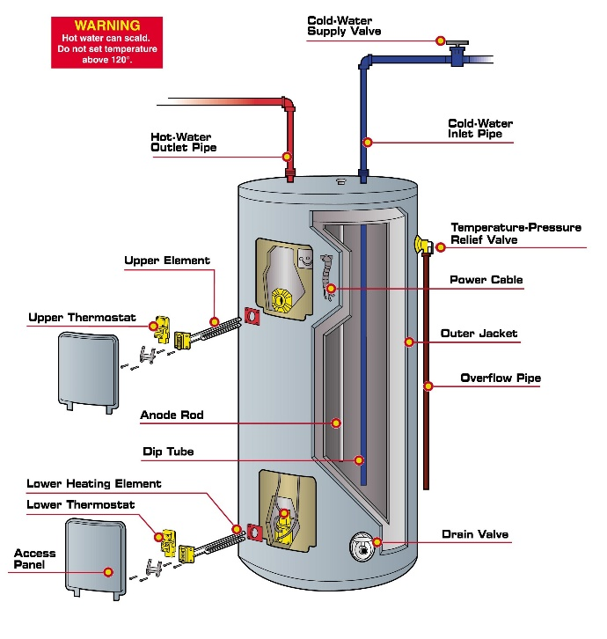
Drain Tank
Depending on local water conditions, draining the tank partially or completely is a recommended maintenance item. Refer to your manufacturer's literature and also consult your plumbing contractor for guidelines and recommendations on the frequency of performing this maintenance according to local conditions.

SAFETY FIRST -Vacuum the area around a gas-fired water heater to prevent dust from interfering with proper flame combustion.
Avoid using the top of a heater as a storage shelf and ensure that there are no combustible items placed near the flame box of the heater which is at the bottom.

Wood Trim
Shrinkage of wood trim occurs during the first two years or longer, depending on the temperature and humidity both outside and inside your home. Wood is more prone to shrinkage during the heating season. Maintaining a moderate and stable temperature and humidity level in your home helps to minimize the effects of shrinkage.

If shrinkage or warping causes a piece of trim to pull away from the wall drive a finishing nail of the appropriate size in to fasten it. Fill the old nail hole with putty or caulk and touch- up with paint as needed.

If the base shoe (small trim between base molding and the floor) appears to be lifting from the floor, this is probably due to slight shrinkage of the floor joists below. You can correct this condition by re-nailing the shoe with a finishing nail of the appropriate size.

Raised Grain
Because of the effects of weather on natural wood, you should expect raised grain to develop. This is normal and not a defect in the wood or paint. Warranty coverage excludes this condition.

- New Home Installations & Maintenance Procedures
- maintenance outside your home

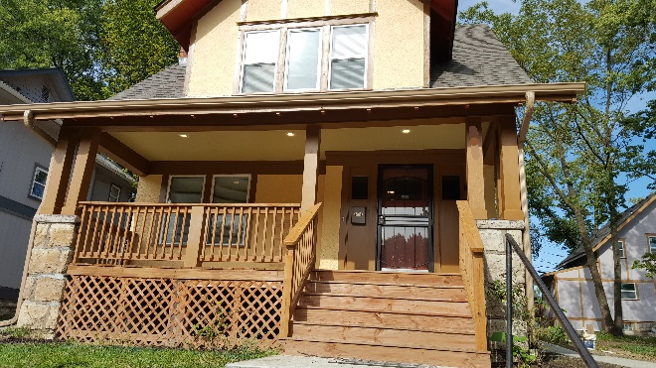
Asphalt
Asphalt is a petroleum based topping. Although asphalt is not rigid like concrete, over time the effects of weather and normal settlement will cause minor movement and cracking of the asphalt.

Heavy Vehicles
Do not allow extremely heavy vehicles such as moving vans or other large vehicles to use your driveways. Your driveways are constructed to accommodate light residential traffic only such as passenger cars, family vans, light trucks, motorcycles and so forth.

Seal-Coating
Over time asphalt will take on a faded appearance which is normal and does not pose a problem and does not indicate a material or structural problem. For purposes of sealing small cracks and for appearance, seal-coat toppings may be applied.

Settling
Where asphalt joins to concrete sidewalks, curbs or garage aprons some settlement will occur and is normal.

Thermal Cracking
Your driveway may exhibit thermal cracking which usually occurs during the first 12 months. These cracks are normal and assist the driveway to adapt to heating and freezing cycles. Cracks should be inspected and evaluated during the hottest months. Cracks that exceed 3 mm (1/8") in width should be repaired and patched.

Caulking
Caulking materials are not "one-time" installations as part of the outside of your home. Over time the materials degrade normally and shrinkage or cracks may appear as building components move with settlement.
It is normal maintenance to check and repair or replace caulking on your home as needed. If the homeowner does not feel competent to perform this maintenance a contractor should be consulted.

Exterior Caulking
Check any caulking at windows, door jams, vents and fireplace vent assemblies as necessary. Repair or replace as appearance and condition indicate, with approved products only.

Concrete Flatwork
Concrete flatwork is any non-load bearing concrete in your home. Typical examples are the garage floor slab, your patio and sidewalks. Small "spider" cracks that may develop are a result of normal concrete shrinkage and are considered normal. The shrinkage occurs during the curing process of the concrete and does not affect the structural performance of the concrete. Larger cracks may be covered within your one year warranty.

Cracks
A concrete slab 3 meters across will shrink approximately 1.5 cm as it cures and that is the cause of the small spider cracks. Some spider cracking of concrete flatwork also results from temperature changes that cause normal expansion and contraction of the concrete.
Concrete slabs in outside areas may get water in larger unsealed cracks and in freezing temperatures may cause frost heaves. To maintain slabs ensure that conditions are dry and then seal the cracks with an approved color-matching sealant.

Expansion Joints
Expansion joints help control expansion and minimize and control cracking. In wet conditions moisture can penetrate under the concrete and lift the expansion joint. If the expansion joint lifts after curing or in later years, fill the resulting gap with an approved color-matching sealant or consult a concrete repair contractor.

Heavy Vehicles
Do not allow heavy vehicles such as moving vans or other large vehicles to use your driveways. Driveways are constructed to accommodate light residential traffic only. The slabs in your new home are residential type concrete intended for passenger cars, light trucks, family vans, etc.

Sealer
Depending on your preferences or environmental conditions homeowners may choose to seal the concrete.

Color
Concrete slabs vary in color owing to differences in the make-up of the concrete, the location they are installed (inside or outside) and the type of finish. No correction is possible or necessary for this condition.

Cracks
Minor cracking (spider cracks) are normal in concrete. If a crack is more than 3 mm (1/8") it will require sealing with an approved caulking compound.

Level Floors
Concrete floors in the habitable areas of the home will be level to within 6 mm (1/4") within any 80cm (32") measurement with the exception of an area specifically designed to slope toward a floor drain.

Separation
Separation of concrete slabs from the foundation of the home should receive attention if the separation exceeds 12 mm (1/2").

Settling or Heaving
If slabs settle or heave in excess of 25 mm (1") or if settlement results in drainage toward the house, contact a concrete professional to re-align the slab.

Spalling (Surface Chips)
Causes of spalling include repeated hosing of concrete for cleaning, animal urine, vehicular radiator overflow, fertilizer, uncleared snow and ice, ice-melting agents and road salts from vehicles. Repair of spalling is a home maintenance task. Homeowners may choose to consult a concrete repair specialist.

Crawl Space
The crawlspace is not intended as a storage area for items that could be damaged by moisture. Wood or other materials that can decompose stored in a crawl space can attract termites or vermin or create odors in the home.

Damp-Proofing
Foundation walls are coated with a drain mat or an asphalt waterproofing material. Careful observation and maintenance of positive drainage will protect your basement from dampness.

Decks
Wood and/or vinyl decks add to the style and function of your home and are a high maintenance part of your home's exterior.

Effects of Exposure
Wood decks are subject to shrinkage, cracking, splitting, cupping and twisting. Nails or screws may work loose and will need seating or tightening to set the heads flush with the wood, as well as routine maintenance. Plan to inspect your decks regularly, at least once each year and provide needed attention promptly to maintain an attractive appearance and forestall costly repairs. It is recommended that you treat or re-stain your decks annually to keep them looking their best.

Foot Traffic
As you use your decks, abrasives and grit on shoes can scratch or dent the wood or vinyl surface. Regular sweeping and using mats can prevent scuffing and abrasion, but will not completely prevent it. High heeled shoes should not be worn on vinyl deck surfaces since the high pressure of the heel may puncture the vinyl membrane.

Outdoor Furniture
The surface of the decking can be damaged by BBQs, deck furniture, or other items such as articles that can rust on outside surfaces. Rust from metal articles can permanently stain some vinyl surfaces. Use caution when moving items to prevent scratches, gouges and punctures.

Sealing Or Water Repellent
To prolong the life and beauty of your deck, treat it periodically with a water repellent or wood preservative. Local home centers or hardware stores offer several products to consider for this purpose. Always follow manufacturer directions carefully.

Snow & Ice
Heavy snow or ice that remains on the deck over long periods increases the likelihood of damage or early failure. Prompt removal can reduce adverse effects. Use caution in shoveling to avoid needless scratching of the deck boards or the vinyl surface.
Stain
Exposed wood decks have been stained to protect and beautify the wood. Each board takes the same stain differently and variations in color will be readily noticeable. Over time, with exposure to weather and use, further variations in color will occur.
Color Variation
Color variations are a natural result of the way in which wood accepts stain and are excluded from limited warranty coverage.
Vinyl Deck Coverings
Vinyl deck coverings act as a membrane to protect sub-structures beneath them from water damage and rot. Vinyl deck coverings require special care to protect against burns, punctures and abrasion. Any penetration of the vinyl decking must be repaired immediately and is the responsibility of the homeowner. Failure to maintain and repair vinyl decking may void warranties on the membrane.

Doors and Locks
The doors installed in your home are wood products subject to such natural characteristics of wood as shrinkage and warpage. Natural fluctuations caused by humidity and the use of forced air furnaces, showers, and dishwashers can affect doors and may require minor adjustments.

Exterior Finish
To ensure longer life for your exterior wood doors, plan to refinish them at least once a year. Stained exterior doors with clear finishes tend to weather faster than painted doors. Treat the finish with a wood preserver every three months to preserve the varnish and prevent the door from drying and cracking. Reseal stained exterior doors whenever the finish begins cracking, crazing or fading.

Failure to Latch
If a door will not latch because of minor settling, make a new opening in the jamb for the latch plate (remortising) and raise or lower the plate accordingly. Also ensure that the hinge screws are tight.

Hinges
You can remedy a squeaky door hinge by removing the hinge pin and applying a silicone lubricant to it. Avoid using oil, as it can gum up or attract dirt.

Locks
Lubricate door locks with silicone spray or another waterproof lubricant. Avoid oil, as it will gum up.

Shrinkage
Use putty, filler, or latex caulk to fill any minor separations that develop at mitered joints in door trim. Follow with painting or staining as required. Panels of wood doors shrink and expand in response to changes in temperature and humidity. Touching up the paint or stain on unfinished exposed areas of wood is your home maintenance responsibility.

Sticking
The most common cause of a sticking door is the natural expansion of lumber caused by changes in humidity. When sticking is caused by swelling during an excessively damp season, do not plane the door unless it continues to stick after the weather changes.

Before planing a door because of sticking, first try tightening the screws that hold the door jamb, doorframe, or hinges. If planing is necessary even after these measures, use sandpaper to smooth the door and paint the sanded area to seal against moisture.

Weather Stripping
Weather stripping, exterior door thresholds and door sweeps occasionally require adjustment or replacement.

Adjustments
Because of normal settling of the home, doors may require adjustment for proper fit.

Foundation
Your builder installs the foundation of your home according to the recommendations of a professional engineer. The walls of the foundation are poured concrete on footings with steel reinforcing rods. The basement floor slab "floats" and is not part of the structural foundation.

Cracks
Through the normal curing process of concrete, surface cracks may develop in the wall. Surface cracks do not affect the structural integrity of your home. If a crack develops in a foundation wall that allows water to come through, contact your builder or follow the procedures for submitting a warranty claim.

Dampness
Due to the amount of water in concrete, basements may be slightly damp, especially if unfinished. Condensation can form on water lines and drip onto the floor, especially from cold water supply lines.

Cosmetic Imperfections
Slight cosmetic imperfections in foundation walls, such as a visible seam where two pours meet or slight honeycombing may occur and require no repair unless they permit water to enter.

Cracks
Shrinkage cracks or backfill cracks are common in foundation walls and are usually noted at the corners of basement windows. Your builder will seal cracks that exceed 3 mm (1/8") width.

Leaks
Your builder will repair any conditions that permit water to enter the basement as long as the homeowner has complied with the drainage, landscaping and maintenance guidelines.

Garage Overhead Door
Since the garage door is a large, moving object, periodic maintenance is necessary.

CAUTION: The door opener springs are under extreme tension. A homeowner should never tamper with or attempt to adjust this mechanism. ALWAYS call a qualified professional to service overhead door springs and mechanisms.

Gaps or Visible Light
Garage overhead doors cannot be airtight like exterior household swing doors. Some light will be visible around the edges and across the top of the door. Some wind, dust, or precipitation may enter around the door.

Lock
If the lock or bolt becomes stiff, apply a silicone spray lubricant.

Lubrication
Every 6 months, apply a lubricant such as silicone spray to all moving parts: track, rollers, hinges, pulleys and springs. Avoid over lubricating to prevent drips on vehicles or the concrete floor. At the same time, check to see that all hardware is tight and operating as intended without binding or scraping.

Painting
Repaint the garage door when you repaint your home if it is a paintable material or as required to maintain and protect the material.

Sag
Garage doors made of wood may sag slightly due to the weight and span of the panels. Sagging is typically not a concern with metal garage doors. The garage door should operate smoothly and easily. If the door becomes misaligned and requires adjustment your builder will make an adjustment unless the problem is caused by the installation of a garage door opener subsequent to closing on the home. If the door was installed after closing your builder will not provide warranty for it.

Gas Shut-Offs
You will find shut-offs on gas lines near their connection to each item that mates on gas. In addition, there is a main shut-off at the meter outside your home.

Gas Leak
If you smell or suspect a gas leak leave the home and call the gas company immediately for emergency service.

Grading and Drainage
The finish grades around your home have been inspected and approved for proper drainage of your lot. Use caution when installing landscaping, fencing, or additions to your home to prevent causing water problems to your home or to homes on adjacent lots.

Drainage
Typically, the grade around your home should slope away from the home (positive drainage). Maintain the slopes around your home to permit the water to drain away from the home as rapidly as possible. Failure to do so may void your warranty.

Exterior Finish Materials
Maintain your soil levels15 cm below siding, stucco, brick, or other exterior finish materials. Deterioration of the exterior finish material can occur from soil or landscaping materials.

Roof Water
Ensure the splash blocks or downspout extensions from under the downspouts are in place. Keep them sloped so the water drains away from your home.
Subsurface Drains
Depending on local requirements or site conditions, builders may install subsurface drainage around the base of the foundation to ensure that surface water drains from a yard adequately. Keep this area and especially the drain cover clear of debris so that the drain can function as intended. If you alter the drainage system after closing, or if changes in the drainage occur due to lack of maintenance you may void your warranty.

Erosion
Your builder is not responsible for weather-caused damage to lots that are not landscaped until after the closing date, or where the final grade is established. Your builder is not responsible for any homeowner landscaping or the plans or installations of the homeowners' landscaping contractor.

Swales
Your builder cannot alter individual lot or development drainage patterns to suit individual landscape plans. Lots typically receive water from and drain water on to other lots. As such changes in grade may affect adjacent lots, homeowners are advised against making changes to the swales or grading.

Gutters and Downspouts
Check gutters occasionally or as weather conditions dictate and remove leaves or other debris. If materials accumulate in gutters, water drainage from the roof can be slowed, or blockages can cause overflows and clog the downspouts.

Extensions Or Splash-Blocks
Extensions should discharge outside of rock or bark beds so that water is not dammed behind the edging materials that might be used. Splash blocks should be maintained with a slope away from the foundation of your home.

Ladders
Be careful when leaning ladders against gutters or you may cause dents. To prevent damage to gutters use appliances for ladders called "roof stand-offs." These are available from building supply stores. Always use caution when using ladders. In particular use caution with metal ladders near electrical power wires or power sources.

Leaks
If joints between sections of gutter drip, clean the inside joint of the gutter and caulk it using an approved gutter caulking compound.

Paint
Gutters and downspouts are painted to match your home. You should repaint them when you repaint your home unless they are a baked enamel finish or colored plastic.

Snow And Ice
Remove excess snow from downspouts as soon as possible to allow the gutter to drain and to prevent blockage, ice and damage. Ice or snow build- up can damage gutters and such damage is not covered by the limited warranty.

Leaks
Your builder will correct gutter leaks that occur during the warranty period.

Overflow
Gutters may overflow during periods of heavy rain. This requires no repair.

Paint and Stain
Painted surfaces should be cleaned and inspected occasionally.

Exterior
Check the painted and stained surfaces of your home's exterior semi-annually or as conditions dictate. Plan on refinishing the exterior surface of your home approximately every two to three years or as often as your paint manufacturer suggests for your area and climate. Some areas such as white painted trim may require annual touch-up.

Severe Weather
Hail and wind can cause damage in a severe storm -always inspect the house after severe weather. If any damage is caused by severe weather, report it to your insurance company. Weather damage is not warrantable.

Railings
Enameled aluminum or wrought iron railings at outside installations require maintenance. Depending on railing type, painting, touch-up and cleaning will be required. Your builder installs railings in positions and locations to comply with applicable building codes. Railings should remain securely attached with normal use. Damage from improper use is not covered by warranty.

Roof
The shingles on your roof do not require any maintenance except to ensure they are kept clear of debris and are intact. The less foot traffic on your roof the less likely it is that problems will occur.

Clean Gutters
Maintain the gutters and downspouts in clean condition free of debris so they are able to quickly drain water from the roof and the building.

Ice Dam
Depending on weather conditions, heat from inside your home can melt snow on the roof. Water then runs down and when it reaches the cold eaves it may freeze. An accumulation of ice can dam the subsequent run-off and the water may begin to back up and may work its way under shingles and ultimately may find its way into your home through windows or ceilings. Damage caused by ice dams are not covered by you warranty.

Leaks
If a roof leak occurs try to detect the exact location while it is leaking. If the source of the leak can be spotted and marked it will make the repair job easier when conditions are dry and the repair can be carried out.

Severe Weather
After severe storms, do a visual inspection of the roof for damages. Notify your insurance company if you find pieces of shingles, or loose roofing tiles in the yard, or if shingle edges have lifted or roof tiles have become damaged or displaced on the roof.

Septic System
Aseptic system consists of two basic parts. The first part is the septic tank and the second is an underground disposal or drainage field. Consult your local septic maintenance contractor for service.

Siding (Cladding)
Siding expands and contracts as changes in humidity and temperature occur. Typically, slight waves are visible in siding under moist weather conditions and shrinkage and separations will be more noticeable under hot or dry conditions. These conditions are normal and do not require attention.

Wood and Wood Products
Wood or wood-product siding may require routine refinishing depending on the type of finish. Some raw wood products may be stained or painted and those should be maintained accordingly. Some wood products may have baked enamel finishes which do not require annual cleaning and painting, but may require touch-ups if damaged. Some wood siding, such as cedar, is subject to more cracking and will require more maintenance.

Vinyl
Vinyl siding requires cleaning. Start at the top and dampen the siding, using only low pressure water and something like a car wash brush. Do not use high- pressure washers or other sources of high water pressure. To avoid streaking use only water and a brush, or use a cleaning product recommended by your siding manufacturer. Follow directions carefully.

Cement Based Products
Cement based siding such as hardi-plank or hardi-board will require repainting and caulking.

Stucco
Stucco is a light weight and thinly applied cement product that is subject to expansion and contraction and therefore may crack. Typically only minor hairline cracks will develop in the outer layer (color coat) of stucco. This is normal and does not reduce the function of the stucco in anyway. If the cracks develop into larger gaps these may require caulking or repair as required. Your builder will repair stucco cracks as required under the terms of your warranty. The repair may not exactly match the surrounding area. If there are signs of water stains coming from the cracks investigate further.

Drainage
To ensure proper drainage away from the stucco keep dirt and concrete flatwork a minimum of 1S cm below the bottom edge of the stucco. Do not pour concrete or install masonry over the bottom edge of the stucco or right up to the foundation since wood members behind the stucco may be damaged by water.

Efflorescence
The white, powdery substance that sometimes accumulates on stucco surfaces is called efflorescence. This is a natural phenomenon where lime in the stucco leeches out. It can be removed by scrubbing with a stiff brush and vinegar or there are commercial products sold to remove efflorescence. One cleaning will not permanently stop efflorescence, it will continue until such time as all the lime has leeched out.

Sprinklers
Since stucco is not a watertight barrier avoid spraying water from irrigation or watering systems directly on to stucco surfaces.

Sump Pump
In some conditions the foundation design includes a perimeter drain and sump pump. The perimeter drain runs around the foundation to gather water and channel it to the sump catchments. When the water reaches a preset level the pump activates and pumps the water out of your home's drainage system. Read and follow the manufacturer's directions for use and care of your sump pump.

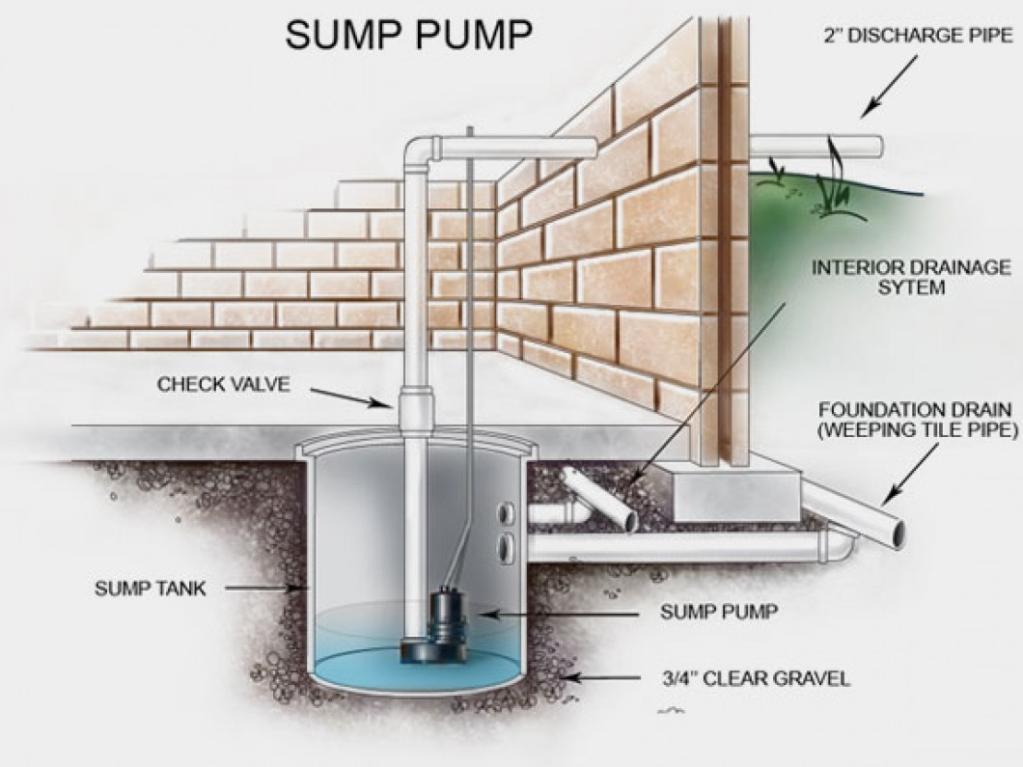

Continuous Operation
The pump may run more frequently or continuously during a heavy storm or long periods of rain. This is normal under such conditions.

Discharge
Locate the discharge point for your sump pump system and keep the end of the drain clear of debris so that water can flow out and away from your home.

Power Supply
The sump pump runs on electricity. If the power goes off, the pump cannot operate. Storm water could then enter your basement.
Homeowners may choose to install a back-up power system to guard against this possibility.

Roof Water
Ensure that roof water drains quickly away from the home to avoid circulating it through your sump pump. Keep downspout extensions or splash blocks in place to channel water away from your home.

Routine Check
Check to confirm the pump is plugged in, the circuit breaker is on and that the pump operates on a regular basis. To test the operation of your sump pump, pour several gallons of water into the sump pump catchments. The pump should come on and pump the water out. Follow this procedure at least once a year.

Ventilation
New homes today are more tightly sealed to the outside environment than older homes. While this improves efficiency there are negative effects such as condensation, cooking odors, indoor pollutants, radon and carbon monoxide may all accumulate. There are both mechanical and passive methods of ventilating homes and minimizing the effects of these factors. It is important that you attend to ventilation maintenance as an important contributor to your health and safety.

Attic Vents
Attics are vented through the soffit (the material installed on the underside of overhangs) or on gable ends. Driving rain or snow can sometimes enter the attic through these vents. Do not cover the vents to prevent minor amounts of water entering. Instead, cover the insulation in front of the vent with a poly plastic covering. By doing this you allow the vent to remain open and the small amount of water that blows in will evaporate safely. If the amount of water is excessive ensure the vent grilles are properly installed.

Crawl Space Vents
Homes with crawl spaces usually include two or more vents through the foundation or between the floor joists. It is important to open crawl space vents for summer months and close them for winter months. Failure to close these vents during the winter and replace the insulation may result in plumbing lines freezing in the crawl space. This occurrence is not covered by your warranty.

Windows, Screens & Sliding Glass Doors
Contact a glass company for re-glazing of any windows that break or repair of any component.

Clean the glass as needed with vinegar and water, a commercial glass cleaner, or the product recommended by the window manufacturer. Always consult the manufacturer's literature and maintenance recommendations if there are special window glazing treatments.

Acrylic or Glass Blocks
Clean acrylic or glass blocks during moderate temperatures using a mild solution of soap and warm water. Wash using a sponge or soft cloth or brush and dry with a towel. Avoid abrasive cleaners, commercial glass cleaner, razors, stiff brushes or scrubbing devices of any kind.

Vinyl Window Frames
Clean vinyl window frames during moderate temperatures using a mild solution of soap and warm water. Wash using a sponge or soft cloth and dry with a towel. Avoid abrasive cleaners, commercial glass cleaner, razors, stiff brushes or scrubbing devices of any kind. From the outside of the home inspect and ensure that the drain (weep) holes are free of dirt or debris and are draining properly.

Aluminum
Clean aluminum metal surfaces with warm, clear water. Do not use abrasive cleaners or steel wool. After each cleaning apply a silicone lubricant with a cloth.

Condensation
Condensation on the interior surfaces of the window and frame is the result of high humidity within the home and low outside temperatures. Lifestyle controls the humidity level within your home and is affected by the number of residents, cooking habits and soon.

Sills
Window sills in your home are typically made of wood and require minimal maintenance which includes repairing minor cracks, keeping paint in good conditions and caulking of the joints.

Sliding Glass Doors
Sliding glass doors are made with tempered glass which is more difficult break than ordinary glass and protects people from injury if broken. Tempered glass breaks into small pieces (popcorn) rather than large splinters or shards which can cause severe injury.

Keep the sliding door tracks clean for smooth operation and to prevent damage to the door frame. Lubricate the tracks with silicone spray lubricant.

Ensure the proper operation of sliding door hardware for maximum security in your home.

Sticking Windows
If sticking occurs or excessive pressure is required to open or close a window, apply a silicone spray lubricant to the tracks. If lubrication does not help investigate further.

Weep Holes (Drain Holes)
During heavy rain, water may collect in the bottom channel of window frames. The weep holes are essential to allow excess water to escape to the outside. Ensure that bottom window channels and weep holes are free of dirt and debris for proper drainage.

Condensation
Condensation that accumulates between the panes of glass in double-glazed sealed windows indicates a broken seal. Your builder will replace the window if this occurs during the applicable warranty period. Many manufacturers provide warranties against seal failure for many years beyond your contractor warranty. If you have a sealed unit failure, after your initial warranty expires consult your manufacturer's literature.

Tinting or Foil Films
If you add tinting or foil films to double-glazed windows all warranties are voided. Damage can result from condensation or excessive heat build-up between the panes of glass. Refer to the manufacturer’s literature for additional information.

Wood Trim
Shrinkage of wood trim occurs normally during the first two years or so depending on ambient temperatures and humidity levels. All wood is more susceptible to drying and shrinkage during the hot summer season. Wood shrinkage can result in separation at joints of trim pieces and cupping or cracking may occur. Homeowners should correct this with caulking and touch-up painting as required.

Shrinkage or cupping may also cause a piece of trim to pull away from the structure. If this happens re-nail the board with an appropriate size finishing nail so as to attach it properly. Fill the nail hole or crack if needed with putty and touch-up with paint.

During your builder orientation (walk-through) your builder will confirm that wood trim is in acceptable condition. Minor imperfections in wood materials are normal with natural products and will require no action.

Exterior
Your builder will caulk and apply touch- up paint to cracks in exterior trim components that exceed 2 mm during your first year of warranty. Your builder will typically perform repair one time only near the end of
The first year or as weather conditions permit. Paint or stain touch-up may not match. Your builder will correct any separation at joints that allows water to enter the home.

Raised Grain
Because of the effects of weather of natural wood, you should expect raised grain to develop. This is normal attribute of wood and not a defect in the wood or paint. Warranty coverage excludes this condition.

- Homeowner Maintenance Recording Log

Date | Maintenance Item & Location | Cost

- Contractor Maintenance Recording Log

Date | Name of Company | Maintenance Item & Location | Cost

- Appliance Service Records and Contacts

Appliance warranties are between the homeowner & the manufacturer (or their representative) directly. For appliance warranty service contact the manufacturer directly.
Appliance Record:
Appliance | Appliance Manufacturer | Model # | Phone # | Serviced
Range
Range Hood
Cooktop
Oven
Microwave
Dishwasher
Garburator
Trash Compactor
Dryer
Washer
Refrigerator
Freezer

Emergency Contact Numbers:
Contact | Emergency | Non-Emergency
Police
Fire
Ambulance
Gas Company
Plumber
Water
Security/Alarm
Telephone/Internet

- Home Maintenance Repair Contractors

Systems | Name | Phones
Air Conditioning
Electrical System
Heating System
Intercom System
Plumbing System
Security System
Septic System
Water Well Mechanical
Appliances | Name | Phones
Built-in Microwave
Clothes Washer & Dryer
Dishwasher
Doorbell System
Fans – Attic, Ceiling & Exhaust
Fire/ Smoke Alarm
Garage Door Opener
Garbage Disposal
Range/Oven/Cooktop
Refrigerator
Trash Compactor
Water Heater
Inside Home | Name | Phones
Cabinetry
Doors, Windows & Trim
Flooring
Carpet
Ceramic/Marble Tile
Wood Floors
Insulation
Painting
Plumbing Fixtures
Outside Home | Name | Phones
Driveway
Gutters & Downspouts
Landscaping
Painting
Roof
Siding
Woodwork

Glossary of Terms

A
ABOVE-GRADE -The portion of a building that is above ground level.
AIR DUCT - Ducts, usually made of sheet metal, that carry air to all rooms.
AIRINFILTRATION - The amount of air leaking in and out of a building through cracks in walls, windows and doors.
AIR FILTERS - Adhesive filters made of metal or various fibers that are coated with adhesive liquid to which the particles of lint and dust adhere. These filters will remove as much as 90% of the dirt if they do not become clogged. The more common filters are of the throw-away or disposable type.
ALLIGATORING -A condition of paint or aged asphalt brought about by the loss of volatile oils and the oxidation caused by solar radiation. "Alligatoring" produces a pattern of cracks resembling an alligator hide and is ultimately the result of the limited tolerance of paint or asphalt to thermal expansion or contraction.
ASPHALT - A dark brown to black, highly viscous, hydrocarbon produced from the residue left after the distillation of petroleum. Asphalt is used on roofs and highways as a waterproofing agent.

B
BATT INSULATION - Strips of insulation· usually fiberglass, that fit between studs or other framing.
BELOW-GRADE -The portion of a building that is below ground level.
BUSTER - An enclosed raised spot evident on the surface of a building. They are mainly caused by the expansion of trapped air, water vapor, moisture or other gases.
BTU - British Thermal Unit-The amount of heat energy required to raise the temperature of one pound of water through a change of one degree F.
C
CAULK - (v) The application of sealant to a joint, crack or crevice. (n) A compound used for sealing that has minimum joint movement capability; sometimes called low performance sealant.
COATING - A layer of any liquid product spread over a surface for protection.
COLLAR - In roofing, a conical metal cap flashing used in conjunction with vent pipes or stacks usually located several inches above the plane of the roof, for the purpose of shedding water away from the base of the vent.
CONDENSATION · the appearance of moisture (water vapor) on the surface of an object caused by warm moist air coming into contact with a colder object.
CONDUCTOR - (1) In roofing, a pipe for conveying rain water from the roof gutter to a drain, or from a roof drain to the storm drain; also called a leader, downspout, or downpipe. (2) In electrical contracting, a wire through which a current of electricity flows, better known as an electric wire.
CONDUCTION - The flow of heat from one part of a substance to another part. A piece of iron with one end placed in a fire will soon become warm from end to end, from the transfer of heat by the actual collision of the air molecules.
CORROSION -The deterioration of metal by chemical or electro-chemical reaction resulting from exposure to weathering, moisture, chemicals or other agents or media.
CRAWL SPACE - An open area between the floor of a building and the ground.
CURB – A short wall or masonry built above the level of the roof that provides a means of flashing the deck equipment
D
DAMPER -Valve for controlling airflow. When ordering registers, make sure each supply outlet has a damper so the airflow can be adjusted and turned off. Dampers maybe either manually or automatically operated. Automatic dampers are required for exhaust air ducts.
DAMPPROOFING -A process used on concrete, masonry or stone surfaces to repel water, the main purpose of which is to prevent the coated surface from absorbing rain water while still permitting moisture vapor to escape from the structure.
DECK - An elevated platform. "Deck" is also commonly used to refer to the above-ground floors in multi-level parking garage.
DEW POINT -The critical temperature at which vapor condenses from the atmosphere and forms water.
DORMER -The house-like structure which projects from a sloping roof.
DOUBLE -GLAZING -In general, any use of two sheets of glass, separated by an airspace, within an opening, to improve insulation against heat transfer and/or sound transmission. In insulating glass units the air between the glass sheets is thoroughly dried and the space is sealed, eliminating possible condensation and providing superior insulating properties.
DOWNSPOUT -The metal pipe used to drain water from a roof.
DRIP EDGE -A device designed to prevent water from running back or under an overhang.
DRYWALL -Sheetrock (gypsum board or gyprock) that covers the framing and is taped, coated and finished to make the interior walls and ceilings of a building.
DUCT -A cylindrical or rectangular "tube" used to move air either from exhaust or intake. The installation is referred to as "ductwork”
E
EAVE -The part of a roof which projects out from the side wall, or the lower edge of the part of a roof that overhangs a wall.
EFFLORESCENCE -The process by which water leeches soluble salts out of concrete or mortar and deposits them on the surface. Also used as the name for these deposits
ELEVATION -A side of a building.
END DAMS -Internal flashing (dam) that prevents water from moving laterally within a curtain wall or window wall system.
EXPANSION JOINT -A device used to permit a structure to expand or contract without breakage.
F
FACADE -The front of a building. Frequently, in architectural terms an artificial or decorative effort.
FACE BRICK - Brick made especially for exterior use with special consideration of color, texture and size and used as a facing on a building.
FASCIA - Any cover board or framed metal assembly at the edge or eaves of a flat, sloping, or overhanging roof which is placed in a vertical position to protect the edge of the roof assembly.
FASTENERS - A general term covering a wide variety of mews and nails which may be used for mechanically securing various components of a building.
FINISH GRADE - Any surface which has been cut to or built to the elevation indicated for that point. The surface elevation of lawn, driveway or other improved surfaces after completion of grading operations.
FLASHING - Weatherproof material installed between roof sheathing (or wall sheathing) and the finish materials to help keep moisture away from the sheathing.
FLASHING, (STEP) -Individual small pieces of metal flashing material used to flash around chimneys, dormers and such projections along the slope of a roof. The individual pieces are overlapped and stepped up the vertical surface.
FLASHING, (THRU-WALL) - Flashing extended completely through a masonry wall. Designed and applied in combination with counter­ flashings, to prevent water which may enter the wall above from proceeding downward in the wall or into the roof deck or roofing system.
FLOOR PLAN - The basic layout of building or addition, which includes placement of walls, windows and doors as well as dimensions.
FOOTINGS - Wide pours of concrete reinforced with re-bar (reinforcing bar) that support foundation walls, pillars, or posts. Footings are part of the foundation and are often poured before the foundation walls.
FURNACE -A heating system that uses the principle of thermal convection. When air is heated, it rises and as the air cools it settles. Ducts are installed to carry the hot air from the top of the furnace to the rooms. Other ducts, called cold air returns, return the cooler air back to the furnace.

G
GABLE -The end of a building as distinguished from the front or rear side. The triangular end of an exterior wall from the level of the eaves to the ridge of a double-sloped roof.
GASKETS - Pre-formed shapes, such as strips, grommets, etc., of rubber or rubber-like composition, used to fill and seal a joint or opening either alone or in conjunction with a supplemental application of a sealant.
GAUGE - The thickness of sheet metal and wire, etc.
GLAZING - (n) A generic term used to describe an infill material such as glass, panels, etc. (v) the process of installing an infill material into a prepared opening in windows, door panels, partitions, etc.
GRAVEL - Loose fragments of rock used for surfacing built-up roofs, in sizes varying from 1/8" to 1 3/4''.
GROUT OR GROUTING –A cement mortar mixture commonly used to fill joints and cavities of masonry or in between tiles.
GUTTER- Metal trough at the eaves of a roof to carry rain water from the roof to the downspout.
GUTTER STRAP -Metal bands used to support the gutter.
H
HATCH - An opening in a deck; floor or roof. The usual purpose is to provide access from inside the building.
HEADER - Framing members over windows, doors, or other openings.
HVAC - Heating Ventilation and Air Conditioning.

I
INSULATION - (1) Generally, any material which slows down or retards the flow or transfer of heat. Building insulation types are classified according to form as loose fill, flexible, rigid, reflective and foamed-in-place. All types are rated according to their ability to resist heat flow (R- Value). (2) In electrical contracting, rubber or thermoplastic wire covering. The thickness of insulation varies with wire size and type of material, application or other code limitations.
J
JAMB - The frame in which a door or window sits.
JOINT – The space or opening between two or more adjoining surfaces.
JOIST - The horizontal framing members that support the floors.
L
LAP - To extend one material partially over another; the distance so extended.
LINTEL - or header - A horizontal piece of wood or steel over an opening such as a window or door to support the walls immediately above the opening. Lintels can also be steel or stone.
M
MEMBRANE · A generic term relating to a variety of sheet goods used for certain built-up roofing repairs and applications.
MOLDING · Finish wood such as door and window trim.
O
OVERHANG - That part of the roof structure which extends horizontally beyond the vertical plane of the exterior walls of a building.
P
PAVER STONES - Usually pre-cast concrete slabs used to create a traffic surface.
POLYURETHANE SEALANT - An organic compound formed by reaction of a glycol with and isocyanate.
PONDING -A condition where water stands on a roof for prolonged periods due to poor drainage and/or deflection of the deck.
POROSITY -The density of substance and its capacity to pass liquids.
PRESSURE TREATED LUMBER –Lumber that is treated in such a way that the sealer is forced into the pores of the wood.
R
RAIL - The top and bottom frame members of a door or window (not the jamb.)
RETURN - In heating and cooling systems, a vent that returns cold air to be warmed. In a hot air furnace system, it is located near an inside wall.
ROOF SYSTEM - General term referring to the waterproof covering, roof insulation, vapor barrier, if used, and roof deck as an entity.
R-VALUE - The thermal resistance of a glazing system. The R-value is the reciprocal of the U-value. The higher the R value, the less heat is transmitted throughout the glazing material.
S
SASH - The window frame, including mounting bars if used, to receive the glazing infill.
SCUPPER - An outlet in the wall of a building or a parapet wall for drainage of water from a flat roof.
SEALANT - An elastomeric material with adhesive qualities applied between components of a similar or dissimilar nature to provide an effective barrier against the passage of the elements.
SHEATHING - Plywood, gypsum or wood fiber encasing walls, ceilings, floors and roofs of framed buildings. It is the first layer of outer wall covering nailed to the studs or rafters.
SHINGLES - Small units of material which are laid in a series of overlapping rows as a roof covering on pitched roofs
SILICONE SEALANT – A sealant having as its chemical compound a backbone consisting of alternate silicon-oxygen atoms.
SILL PLATE - The framing member anchored to the foundation wall upon which studs and other framing m embers will be attached. It is the bottom plate of your exterior walls.
SILL STEP - The first step coming directly off a building at the door openings.
SKYLIGHT - A structure on a roof that is designed to admit light and is somewhat above the plane of the roof surface.
SLAB ON GRADE -A type of construction in which footings are needed, but little or no foundation wall is poured.
SLOPE - Incline or pitch of roof surface.
SOFFIT - The underside of a part or member of a building extending out from the plane of the building walls.
SPALLING -The chipping or flaking of concrete, bricks, or other masonry where improper drainage or venting and freeze/thaw cycling exists.
SPLITTING -The formation of long cracks completely through a membrane. Splits are frequently associated with lack of allowance for expansion stresses. They can also be a result of deck deflection or change in deck direction.
STACK -The vertical pipe of a system of soil, waste or vent piping.
STUCCO – A type of cementitious exterior finish.
SUB-FLOOR - Material (such as particleboard) installed before finish flooring materials.
SUBSTRATE - A part or substance which lies below and supports another.
T
THERMAL MOVEMENT - The measured amount of dimensional change that a material exhibits as it is warmed or cooled.
TOOLING - The operation of pressing on a sealant in a joint to press the sealant against the sides of a joint to secure good adhesion; the finishing off of the surface of a sealant in a joint so that it is flush with the surface.
TUCK POINTING -The re-grouting of defective mortar joints in a masonry or brick wall.
U
ULTRAVIOLET -The invisible rays of the spectrum of light which are at its violet end. Sometimes abbreviated U.V.
V
VAPOR -The gaseous form of any substance.
VAPOR RETARDER (BARRIER) -A membrane which is placed between the insulation and the roof deck to retard water vapor in the building from entering the insulation and condensing into liquid water.
VENT PIPE -A vertical pipe of relatively small dimensions which protrudes through a roof to provide for the ventilation of gasses.
VENTING -The process of installing roof vents in a roof assembly to relieve vapor pressure; the process of water in the insulation course of the roof assembly evaporating and exiting via the roof vents.
VENT STACK - A vertical vent pipe installed for the purpose of providing circulation of air to and from any part of a drainage system.
VENT SYSTEM - In plumbing, a system to provide a flow of air to or from a drainage system or to provide circulation of air within such system to protect trap and seals from siphonage and back pressure.
W
WALKWAYS -Designated areas for foot traffic. WATER VAPOR - Moisture existing as a gas in air.
WEEP HOLE - A hole which allows for drainage of entrapped water from masonry or glazing structures.
WET SEAL - Application of an elastomeric sealant between the glass and sash to form a weather tight seal.
WIND UPLIFT -The upward force exerted by wind traveling across a roof.

Notes

